Title: What makes people laugh? (Zihan Zhang)
Problem Description
In standing comedy, a performer deliver jokes to trigger laughter from the live audience. Laughter is one of the most direct indicators of audience response in comedy performance. In standing comedy, a successful joke is often evaluated not by its content alone, but by the audience’s laughter—how long it lasts and how loudly it erupts. While humor research has extensively examined joke comprehension in cultural, linguistic and social aspects, relatively less attention has been given to the acoustic delivery of the speaker and its relationship with audience laughter responses. This raises a central question: beyond what is being said, how does the way something is said influence laughter?
Understanding this relationship is both theoretically and practically significant. From a psychological perspective, laughter reflects important individual and social emotions. Identifying acoustic features of delivery influences laughter contributes to the broader study of emotion and communication. From a practical point, comedians and public speakers may benefit from empirical insights into how to tailor their vocal strategies to achieve expected laughter effect.
The purpose of this project is: first, build a machine learning model capable of detecting laughter segments in stand-up comedy recordings using acoustic features. Second, based on detected laughter, quantitatively examine the relationship between acoustic features of speakers and audience laughter outcomes. Hopefully, it can provide an empirical framework linking acoustic features of speakers with measurable emotional responses. Such a framework may inform performance training, contribute to computational humor research, and offer a foundation for future psychological studies.

Background
Research on comedy and laughter spans both psychology and sociology, with foundational work emphasizing the cognitive and social factors underlying humor. Robert R. Provine (2000), through large-scale naturalistic observations and audio recordings of spontaneous interactions, demonstrated that laughter is mostly a social and interaction-driven behavior rather than a simple response to jokes. Peter McGraw (2010) used controlled experimental manipulations to explain how humor emerges when a situation is perceived as both norm-violating and harmless. While these approaches have substantially advanced our understanding of when and why humor occurs, most rely on laboratory experiments or observation and focus primarily on cognitive processes. Comparatively little research examines the performative aspect of comedy—specifically, how comedians’ vocal delivery shapes audience responses. Few studies quantitatively link acoustic features of speech, such as pitch, energy variability, and rhythm, to measurable variations in laughter intensity. To address this gap, the present study analyzes real-world comedy performances to test how vocal features of speakers predict laughter duration and volume, thereby integrating humor theory with acoustic analysis of live audience reactions.

Data Description and Preprocessing
244 standing comedy videos are collected from YouTube and converted into .wav format (audio recordings). Each video contains alternating segments of speaker (comedian) speech and audience laughter.
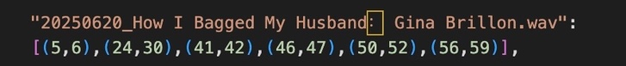
From the full dataset, 30 recordings are randomly selected. For the first minute of the selected recordings, laughter segments are manually annotated by marking the start and end timestamps (in seconds). For example, if a laughter segment spans from 5th to 6th second, this interval (5, 6) is labeled as a laughter.
To align annotations with acoustic features, time-based labels are converted into frame-level labels using:
$$frame index= \frac{time × sr}{hop length}$$
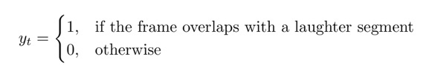
where sampling rate (sr) is the number of samples per second; hop length = 512 (i.e., frames are spaced every 512 samples).
and frame is classified to 1 = laughter, 0 = non-laughter
Six features are extracted for each frame as parameters for machine learning. These features are designed to capture both overall sound characteristics and temporal variations.
Static Features: Root Mean Square Energy (RMS): the loudness of sound; Zero Crossing Rate (ZCR): the sharpness of sound; Spectral Centroid (Centroid): the brightness of sound.
Dynamic Features: Delta RMS: sudden burst or stable sound; Delta Centroid: fluctuation of tone color; Spectral Flux (Flux): the fluctuation of pitch spectrum.
Before modeling, parameters are standardized to prevent dominance by large-scale features.
Method
- Model Training and Selection
The 30 selected recordings are split into 4:1 ratio, with 24 recordings for training and 6 for testing. Four classifiers are trained: Logistic Regression, KNN, Decision Tree, Random Forest. Because most of the time in audio recordings is when comedians speaking, the distribution of laughter and non-laughter is highly imbalanced. To address this, hyperparameters are selected using ROC-AUC scores in the Grid Search with 5-cross-validation. Final model performance is then assessed on the 6 testing set using Test AUC and F1-score.
Table 1: Comparison of Classification Models for Laughter Detection
Models & Parameters/Performance | Best CV AUC | Test AUC | F1
Logistic Regression (‘C’: 46.42) | 0.6386 | 0.6489 | 0.3561
KNN (‘n_neighbors’: 196) | 0.7583 | 0.7124 | 0.2544
Decision Tree (‘max_depth’: 10) | 0.7344 | 0.6994 | 0.4032
Random Forest (‘max_depth’: 10) | 0.7609 | 0.7161 | 0.4166
As shown in the table. Logistic Regression achieves CV and Test AUC around 0.64, indicating limited discrimination ability. Nonlinear models: KNN, Decision Tree, Random Forest achieve CV AUC above 0.73, demonstrating acceptable discrimination ability, showing that nonlinear models better capture the acoustic features associated with laughter. However, for these 3 nonlinear models, there is noticeable decrease from CV AUC to Test AUC (KNN: 0.0459, Decision Tree: 0.035, Random Forest: 0.0448), suggesting potential overfitting—some patterns learned in cross-validation may not generalize perfectly to unseen recordings.
Among four models, Random Forest is selected as the final model. First, its CV AUC scores rank the first (0.7609), indicating strong discrimination ability; Second, it achieves the highest Test AUC (0.7161), suggesting better generalization ability compared to other nonlinear models; Third, its F1 score is the highest (0.4166), indicating a balance between precision and recall.
- Laughter Detection and Feature Extraction
The trained model is applied to the full dataset (244 recordings) to detect laughter for every frame (labels: 1 = laughter; 0 = non-laughter, which is treated as speech frame). Based on these labels, for each recording, laughter features are extracted from laughter frames, speaker features are extracted from non-laughter frames, and together they are restored in a CSV file (‘laughter_analysis_results.csv’).
Laughter features (predictors):
Laughter duration: Continuous laughter frames are grouped into segments, the mean duration of every segment is calculated in seconds as laughter duration.
Laughter volume: The mean volume of laughter frames, measured in dB.
Speaker features:
Onset Rate: rhythmic activity
Expressiveness: combination of pitch and energy, reflecting emotional animation
Pitch Variability: intonation changes
Energy Variability: variation in loudness
- Analysis of Speaker-Laughter Relationship
To examine the relationship between speaker features and laughter outcomes, regression-based approaches are adopted, including: Ordinary Least Squares (OLS) Regression, Lasso Regularization, Principle Component Analysis (PCA) and PCA Regression.
OLS regression is first applied to estimate the linear relationships between 4 speaker predictors (onset rate, expressiveness, pitch variability, energy variability) and laughter outcomes. Laughter duration and volume are estimated separately as dependent variables.
However, Variance Inflation Factor (VIF) demonstrates severe multicollinearity among predictors: VIFs were 1007 for pitch variability, 981 for expressiveness, 171 for energy variability, and 14 for onset rate, substantially exceeding conventional thresholds (VIF > 10), indicating that OLS regression coefficients might be unstable. Therefore, Lasso regression with cross validation is conducted to shrink unstable coefficients. In addition, PCA is applied to transform linearly dependent predictors into orthogonal components and reveal latent acoustic dimensions.

Final Results
- OLS Regression

OLS regression results for laughter duration: F(4, 239) = 95.87, p < 0.001, R² = 0.616 (adjusted R² = 0.610).
The result shows that overall, the multiple linear regression model predicting laughter duration from the four predictors is statistically significant. p < 0.001, indicating that we can reject the null hypothesis. The model explained 61.6% of the variance in the laughter duration (R² = 0.616), suggesting a strong explanatory power. Energy variability is the most significant positive predictor (β = 0.193, t = 6.99, p < 0.001), followed by expressiveness (β = 0.138, t = 2.73, p = 0.007) and pitch variability (β = 0.118, t = 2.21, p = 0.028). Onset rate showed a significant negative relationship (β = −0.295, t = -2.07, p = 0.039).
OLS regression results for laughter volume: F(4, 239) = 65.42, p < 0.001, R² = 0.523 (adjusted R² = 0.515).

Similar to laughter duration, the result shows that multiple linear regression model predicting laughter volume from the four acoustic variables is statistically significant and has a moderate explanatory power (R² = 0.515). Pitch variability is a significant positive predictor (β = 0.460, t = 3.91, p < 0.001), whereas energy variability is a significant negative predictor (β = −0.897, t = -14.72, p < 0.001). Onset rate (p = 0.718) and expressiveness (p = 0.123) do not significantly predict laughter volume.
- Lasso Regression
Lasso coefficients for laughter duration—onset rate: -0.003, expressiveness: 0.019, pitch variability: 0.011, energy variability: 0.019
Best α (optimal penalty parameter) = 0.00087, R² = 0.613.
For laughter duration, the optimal penalty parameter (α = 0.00087) produces R² = 0.613, closely matching the OLS model. Coefficient of onset rate is substantially shrunk, approaching zero (-0.003), suggesting that its contribution depends on other predictors.
Lasso coefficients for laughter volume—onset rate: -0.001, expressiveness: 0.002, pitch variability: 0.065, energy variability: -0.094. (Best α = 0.00088, R² = 0.522)
For laughter volume, Lasso (α = 0.00088) produces R² = 0.522, closely matching OLS model. Coefficients of onset rate and expressiveness approach zero, showing their contributions are dependent on other predictors.
Results of Lasso regression indicate that although OLS models are predictive, shared variance among predictors makes it difficult to isolate their independent contributions.
- PCA
The first principal component (PC1) accounted for 79.31% of the total variance, and the second principal component (PC2) accounted for an additional 11.75%, together explaining 91.06% of the variance.
PC1 showed positive loadings across all variable, reflecting a dimension characterized by simultaneous increases in rhythmic activity (onset rate = 0.495), emotional expressiveness (expressiveness = 0.520), pitch variance (pitch variability = 0.536) and volume variance (energy variability = 0.444).
PC2 was dominated by a strong positive loading from energy variability (0.887) and negative loadings from pitch variability (−0.327), expressiveness (−0.302) and onset rate (-0.125), indicating a dimension marked by substantial fluctuations in volume with stable pitch, emotional expression and rythmic activity.
OLS regression result using PC1 as the predictor for laughter duration: F(1, 242) = 306.50, p < 0.001, R² = 0.559.
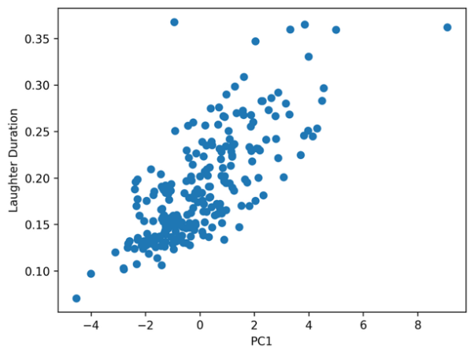
Figure 1: Relationship between PC1 and Laughter Duration
PC1 significantly predicts laughter duration (p < 0.001) with positive coefficient (β = 0.023). This finding indicates that longer laughter episodes are associated with higher overall fluctuations in rhythmic activity, emotional expression, pitch and volume. However, PC1 does not significantly predict laughter volume (p = 0.248), but regression using PC2 produces a significant model for laughter volume prediction.

OLS regression result using PC2 as the predictor for laughter duration: F(1, 242) = 253.00, p < 0.001, R² = 0.511.
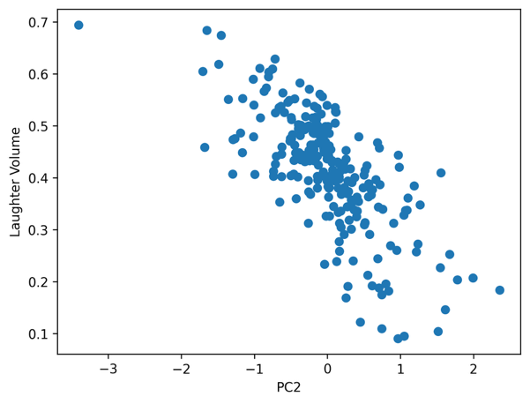
Figure 2: Relationship between PC2 and Laughter Volume
PC2 is a strong negative predictor (β = −0.115, t = −15.91, p < 0.001) for laughter volume. This result suggests that louder laughter is associated with stable volume but fluctuated rhythmic activity, pitch and emotional expression of speakers.

Discussion
The findings of this study suggest that different acoustic patterns of speakers are associated with distinct features of audience laughter. First, speakers who present higher acoustic activity—stronger rhythm, richer emotional expression, greater pitch movement and energy shifts tend to elicit longer laughter episodes. In simple terms, more animated and dynamically expressive speakers make audience laugh for a longer duration. Second, results indicate that louder laughter is associated with relatively stable energy but greater variation in rhythm, pitch and emotional expression. In other words, when speakers maintain stable loudness but vary their tone, rhythm and emotional expression, audience tend to laugh louder. Taken together, excited and energetic speakers can produce longer laughter bursts, whereas speakers who skillfully vary tone and rhythm within controlled energy may elicit louder laughter responses.
These findings offer potential applications for stand-up comedians. By identifying acoustic features associated with longer and louder laughter, this study provides empirical guidance on their effective vocal delivery strategies. For example, excessive or unstable volume may not increase laughter loudness. Beyond performance practice, the study also contributes to quantitative humor research by providing a bridge between acoustic humor performance (speaker features) and emotional response (laughter features). It establishes a foundation for future interdisciplinary studies integrating acoustics, psychology and comedy.
Several limitations should be acknowledged: First, the training dataset is relatively small. Although 244 recordings were collected, only 30 were manually annotated, and only the first minute of each recording was labeled. These data are insufficient for robust generalization. Second, laughter detection in real-world audio is challenging. Comedy recordings contain overlapping sounds, including speaker voice, audience voice, applause, background music and environmental noise. The extracted acoustic features may be contaminated by these factors, reducing detection accuracy. Third, acoustic features of speakers alone may not fully explain audience laughter. Humor perception depends on social and linguistic factors such as cultural context and punchlines, which are not included in this study. To develop this project into an academic study, several extensions can be considered: first, expand the annotation dataset to improve model stability; second, incorporate noise reduction preprocessing to exclude its influence on acoustic features; third, combine acoustic analysis with natural language processing of joke content and timing of punchlines to address the contextual features; fourth, test whether the present findings generalize or not across different comedians, comedic genres such as short videos and media platforms such as Tiktok and Wechat.

References
Provine, R. R. (2000). Laughter: A scientific investigation. New York, NY: Viking.
McGraw, A. P., & Warren, C. (2010). Benign violations: Making immoral behavior funny. Psychological Science, 21 (8), 1141–1149. https://doi.org/10.1177/0956797610376073
Source of videos: https://www.youtube.com/@OfficialLaughSociety/videos

